SPECIAL PROJECTS GUIDE
4th Year — Module 2A
A Guide for Incoming Exchange Students
By Lisane Valdo — 4th Year Coordinator

Lisane Valdo
Lisane.valdo@prof.inteli.edu.br

Welcome to Special Projects!
This program is designed to give you real hands-on experience with a market partner. Make the most of it engage with your team, communicate clearly with your partner, and use every Sprint presentation as a chance to show your progress.
1. Program Overview
Special Projects is the capstone experience of Inteli's 4th year. Instead of a traditional classroom project, you will work directly with a real company from the market, tackling a real business problem, over a 10-week, 5-Sprint program conducted entirely in English.
Key facts
Duration: 10 weeks
Structure: 5 Sprints (2 weeks each)
Language: English
Partner: one real company per group, from a live market problem
Groups: your class is divided into small groups — each group works with a different partner company on a different project (see Section 3)
Deliverables: submitted via GitLab
Grading: one grade per Sprint; final grade = average of all Sprint grades

2. Program Timeline
The program is organized into five two-week Sprints. Each Sprint ends with a delivery and a presentation to your partner company, who evaluates your progress and gives you a grade for that Sprint.
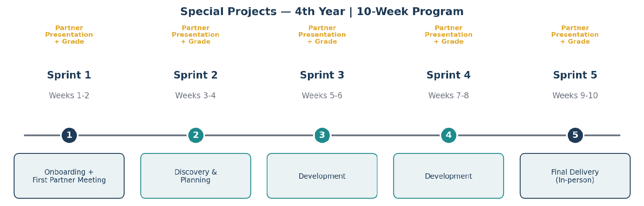
Figure 1 — The 10-week / 5-Sprint journey, from onboarding to final delivery.

Weeks 1–2: Getting started
- Week 1 — Onboarding: you meet your professor/advisor, review the Project Charter (TAPI), and get set up with all the tools you'll use, including GitLab.
- Week 2 — First conversation with your partner company: your group meets the partner for the first time to align expectations, understand the business context, and refine the project scope.
By the end of Week 2 (end of Sprint 1), your group delivers its first Sprint and presents initial progress to the partner.

Weeks 3–10: Sprints 2 through 5
- Each subsequent Sprint also lasts 2 weeks and ends with a delivery plus a presentation to the partner.
- Sprint 5 (Weeks 9–10) is the final Sprint: your group delivers and presents the finished project to the partner.

3. Your Group and Partner Company
Each group is paired with one partner company and works on that company's project for the entire program. No two groups share the same project or the same partner. Below is the current list of groups and partner companies for this cohort.
Group | Partner Company | Project Scope
Group 1 | YvY Capital | Automated, governance-compliant data pipeline consolidating fund profitability, portfolio composition, and performance.
Group 2 | Verse | Web application for women 40+ navigating skin changes, with a skincare journey and digital skin diary.
Group 3 | Dow Brasil | Digitalizing paper-based quality control records through a web solution with data logging and photo evidence.
Group 4 | Galateia | Web application for a contemporary art gallery: artwork registration, vehicle recommendation, route calendar, and shipment tracking.

Good to know
Your professor/advisor will confirm your group's detailed scope and expected deliverables during onboarding — the scope above is a summary.
If anything about your group or partner seems unclear, check with your professor before reaching out to the partner directly.

Your Professor and Teammates
Each group has one professor/advisor guiding the project. Find your name below to confirm your group, professor, and teammates.
Group | Partner Company | Professor | Students
Group 1 | YvY Capital | Marcelo Desterro | Adrien Cognet, Isiah Perelman, Thomas Duberseuil-Guerin, Viktor Suzyumov, Raphael Lefevere
Group 2 | Verse | Julia Stateri | Aureliene Kammerer, Emma Durand, Nina Authier, Johlan Lepy
Group 3 | Dow Brasil | Hermano Peixoto | Alexis Tentenier-Marionneau, Romain Nunes, Rose Francois, Evie Farfra-Jallet, Mélina Hadjaz
Group 4 | Galateia | Bruna Mayer | Celestin Desnoues, Henri Hager, Lukas Bécue, Antoine Bray-Moreau, Paul Gorioux

4. How a Sprint Works
Every Sprint follows the same rhythm, so once you go through Sprint 1, the rest will feel familiar.
- Sprint 1. Planning: at the start of the Sprint 1, your group and your professor define what will be delivered.
- Sprint2 to 5. Work: your group develops the agreed deliverables together, using GitLab to track and submit progress.
- Deliver: you submit your Sprint deliverables in GitLab before the deadline.
- Present: your group presents the Sprint's results to the partner company.
- Grade: the partner and your professor evaluate the Sprint and assign a grade.

Partner presentations — in person or online
Presentations happen at the end of every Sprint.
The format (in-person or online) depends on the partner's availability and schedule.
Sprint 1 and Sprint 5 presentations are, whenever possible, held in person — exact dates are confirmed by the Project Office together with the partner.
For the other Sprints, your professor will let you know in advance whether the session is in person or online.

5. Deliveries on GitLab
All Sprint deliverables, documents, code, and other artifacts are submitted through GitLab. This is the single source of truth for your group's work and progress throughout the program.
Accessing GitLab
You will receive your GitLab access by email, sent to your Inteli institutional address.
Access is granted once your institutional email is active, usually shortly after your arrival.
Keep an eye on your inbox during the first days of the program; if you don't receive access, tell your professor or the Project Office.
Submit each Sprint's deliverables to your group's GitLab repository before the Sprint deadline.

6. Grading: How Your Final Grade Is Calculated
Each of the five Sprints is graded individually, based on your delivery and your presentation to the partner. Your final grade for Special Projects is simply the average of all five Sprint grades.
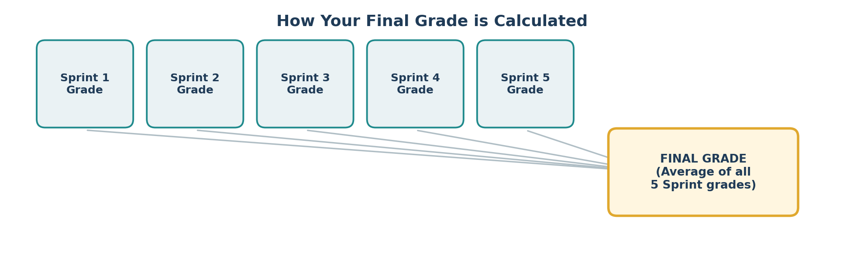
Figure 2 — Final grade = average of the five Sprint grades.
In short
5 Sprints → 5 grades → 1 final grade (the average).
There is no separate final exam: consistent work across every Sprint is what builds your final grade.

7. Need Help?
If you have any questions about scope, schedule, partner communication, or GitLab access, talk to your professor/advisor first.
For anything involving the partner's agenda or broader program logistics, your professor will coordinate with Inteli's Project Office (Escritório de Projetos) on your behalf.

